**Proposal for Interdisciplinary Team Project**

**BSHC(E)2, BSHBIS(E)2, HCC(E)2, BSHTM2, HCBC2**

|  |  |
| --- | --- |
| **Project title:** | AAA (Audio Acoustic Assistant) |
| **Group:** | Group 14 |
| **Project manager:** | Cedric Vecchionacce |
| **Team members:** | Colin Allen,  Keith Feeney,  Patrick Lawlor,  Fearghal McMorrow,  Cedric Vecchionacce |

Contents

Overview 3

Target group 3

Market Analysis 3

Functionality 3

Mock-up 4

Project Plan 4

Literature Review 5

Summary 5

Mock-Ups 6

App: 6

Web Site: 6

References 7

# Overview

The project is to build an audio acoustic application; the aim of the application is to create the perfect environment for noise control. By giving the user a step by step guide and the fundamental tools and formulas needed to perform a professional acoustic treatment in a room and achieving the best environment for sound quality when recording.

# Target group

With the current trends on digital multimedia and marketing, tools and good methods are a must. The app will provide this market with a toolkit to improve production environments and will be used as a tool for those who wish to adjust the sound acoustic and sound quality of their environment.

The target group would be YouTubers, Voice actors, Musicians, Music producers, and Venues (For Concerts and Presentations), at any level of expertise.

There are no skills or prior-knowledge required to use our software. We are aiming for a large demographic that includes amateurs and professionals alike.

The target audience would want to use our software to create an ideal acoustic environment suitable for recording, broadcasting, and noise control.

The tools and formulas will be separated based on target group; YouTubers will need access to different calculations to Musicians. Therefore, users can separate themselves into different roles based on which calculations they need access to.

# Market Analysis

There are applications that work with audio in similar ways, e.g. for tuning guitars and audio equipment. However, there aren’t any applications which guide and teaches the user how to perform a proper acoustic treatment for a room. The proposed idea is unique and has a more specific use case, from any other audio application in the market. Our application could incorporate audio calculations for proper equipment installation, to compete with the current market, however that would be implemented after the initial release.

# Functionality

The software will be able to improve a room(’s) sound quality and to enhance the user’s audio production environment, by providing them with a step-by-step guide using a set of calculations.

The application will be able to perform audio calculations such as;

* Sound pressure level.
* Absorption factor.
* Reverb time (before and after treatment).

The software will not be capable of tuning instruments, mixing, DJ-ing, editing, creating radio stations.

# Mock-up

Please see attached files in the folder “Mock-up”.

The languages used in the project will be Java, SQLite, HTML5, CSS, jQuery, JavaScript, Ajax and PHP.

# Project Plan

Please see attached file: “Project Plan.mpp”.

All group members will have their own work to do. All will do different sections in

The work required includes:

* Complete proposal
  + Scope
  + Analysis / Software requirements
* Elicitate and analyse requirements
* Coding / aesthetics of app
* Testing (Beta testing)
* Finalise prototype
* Presentation for peer-review
* Bug fixes / Improvements
* Post implementation analysis

There are plenty of similar apps on the likes of the Google Play Store.

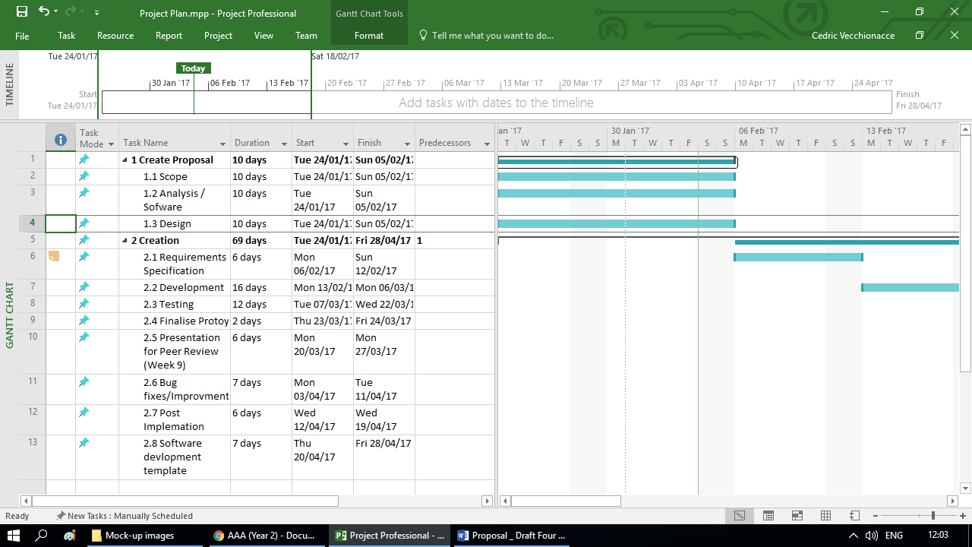

## Literature Review

**AGC Acoustics**. This app gauges the sound but only with window glass. Our app will be be used with any surface, so it will be a great improvement. The comments on the app say that it’s “very useful”. (Google; AGC Glass Europe, 2017)

**ClapIR.** This is a very similar tool app to ours. However, the main difference is that the user needs to clap to test the acoustics of a room. ClapIR is like a very basic version of our app. It’s like as if this is a starting point for our app. Many users who have downloaded the app say that it doesn’t work or it’s not precise. (Google; seeth, 2017)

**toolBox for acoustics.** This app is also very similar to ours. But the main difference is that this app is slow, can become unresponsive and contains many bugs. Some comments say they are unable to scroll within the app or are unable to insert a decimal point. This app allows users to insert their own values, while our app with have pre-set values, making it simplified for users. (Google; acoustassist ltd., 2017)

# Summary

**Overall, what is the benefit of this software? Are there any risks involved?**

The benefit of the software is to give people the opportunity to correctly establish the room sound quality. This will benefit them in producing media. Some risks include:

* Similar app found on Google Play Store (But quality is not very good. For example; their app freezes and becomes unresponsive)
* Regarding the similar app, that app only has 10,000 downloads, same fate could potentially happen our app. However, a good marketing plan would increase the downloads.

# Mock-Ups

## App:

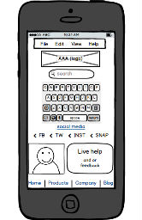 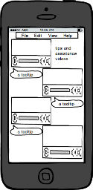 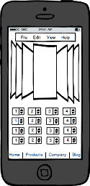

## Web Site:

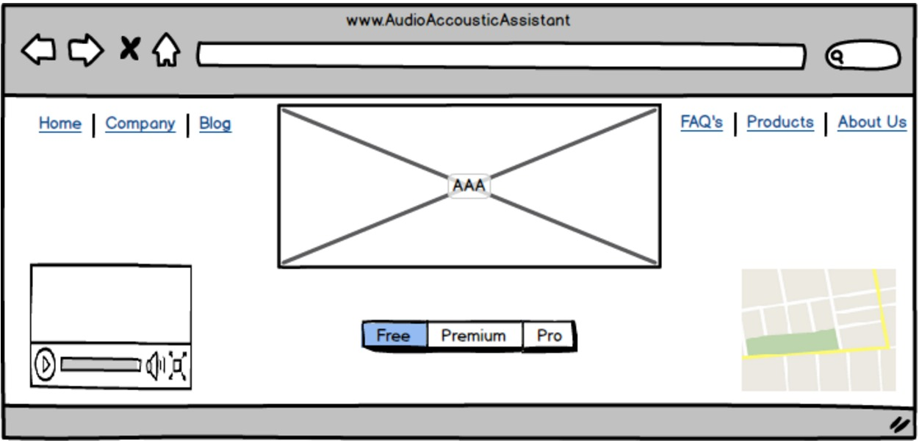

# References

Google; acoustassist ltd., 2017. *toolbox for Acoustics.* [Online]   
Available at: https://play.google.com/store/apps/details?id=com.acoustassist.toolBox  
[Accessed 1 February 2017].

Google; AGC Glass Europe, 2017. *AGC Acoustic.* [Online]   
Available at: https://play.google.com/store/apps/details?id=eu.agcglass.acoustic  
[Accessed 1 February 2017].

Google; seeth, 2017. *ClapIR.* [Online]   
Available at: https://play.google.com/store/apps/details?id=com.seeth.clapir  
[Accessed 1 February 2017].